

CAPSTONE PROJECT REPORT
Report 3 – Software Requirement Specification

– Hanoi, August 2019 –
Table of Contents
I. Project Report 3
1. Status Report 3
2. Team Involvements 3
3. Issues/Suggestions 3
II. Software Requirement Specification 4
1. Overall Description 4
1.1 Product Overview 4
1.2 Business Rules 5
2. User Requirements 6
2.1 System Actors 6
2.2 Use Cases 6

I. Record of Changes
Date | A*  M, D | In charge | Change Description
*A - Added M - Modified D - Deleted

II. Software Requirement Specification

1. Product Overview
[Gives the overall description about the product with some introduction and the context diagram. The context diagram presents the boundary and connections between the system you’re developing and everything else in the universe. This identifies external entities (or terminators – software, hardware, human components, and other systems) outside the system that interface to it in some way, as well as data, control, and material flows between the terminators and the system.]
<<Sample: The Cafeteria Ordering System is a new software system that replaces the current manual and telephone processes for ordering and picking up meals in the Process Impact cafeteria. The context diagram below illustrates the external entities and system interfaces for release 1.0. The system is expected to evolve over several releases, ultimately connecting to the Internet ordering services for several local restaurants and to credit and debit card authorization services.
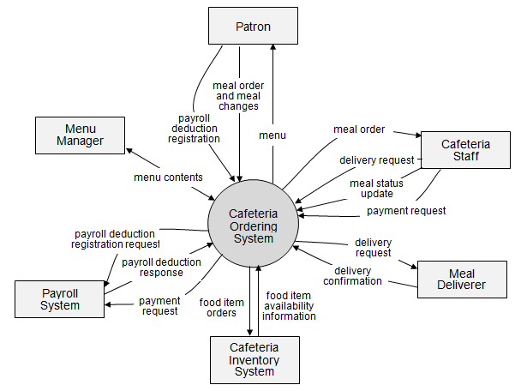
>>

2. User Requirements

2.1 Actors
[An actor is a person (or sometimes another software system or a hardware device) that interacts with the system to perform a use case. Following are some questions you might ask to help user representatives identify actors
- Who (or what) is notified when something occurs within the system?
- Who (or what) provides information or services to the system?
- Who (or what) helps the system respond to and complete a task?
This part gives the description of system actors, you can follow the table form as below]
# | Actor | Description
1 | Administrator
2 | Menu Manager
3 | …

2.2 Use Cases
[A use case (UC) describes a sequence of interactions between a system and an external actor that results in the actor being able to achieve some outcome of value. The names of use cases are always written in the form of a verb followed by an object. Select strong, descriptive names to make it evident from the name that the use case will deliver something valuable for some user]

2.2.1 Diagram(s)
[Provide the UC diagram(s) to show the actor-UCs and UC-UC relationships like the sample below. You can have multiple UC diagrams for the system]
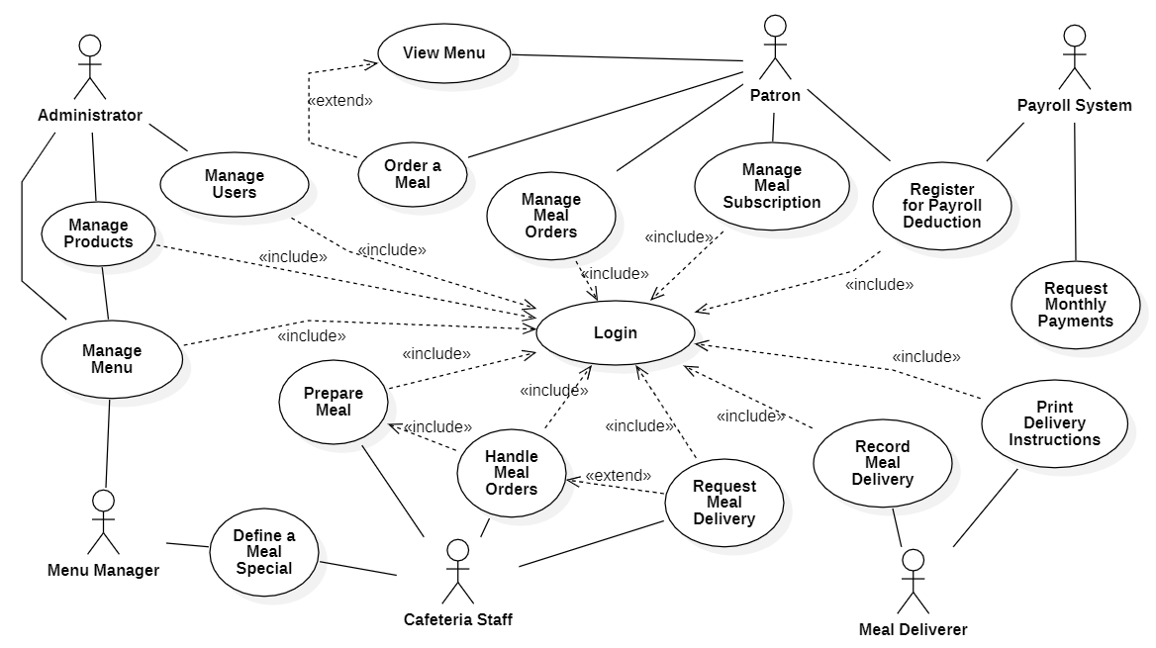

2.2.2 Descriptions
This part describes the use cases, you can follow the table form as below]
ID | Use Case | Actors | Use Case Description
01 | View Menu | Patron
02 | Order a Meal | Patron
03 | …

